The Rise of Young Adult Poverty in the U.S.
James Hawkins, MPP ‘18
Associate Director, Berkeley Institute for Young Americans
The U.S. social safety net helps to lift millions of people out of poverty through programs like the Earned Income Tax Credit, Social Security, and the Supplemental Nutrition Assistance Program. These programs target benefits to individuals and families using factors like income (means-testing), parenthood, and employment status. For many anti-poverty programs, age is also an important factor for eligibility – either implicitly or explicitly. The Social Security Retirement Insurance Benefit program is explicitly designed around senior income security. Likewise, the Earned Income Tax Credit focuses expenditures on families with children – implicitly deprioritizing many working-age adults who have not yet had children. We accept that a social safety net is necessary for the youngest and the oldest in our society because, historically, poverty has been highest among these groups – those not in the workforce and most vulnerable. But the shape of poverty in this country has changed: what if the social safety net is missing a key age group?
Measuring Poverty across the Age Distribution
To better understand the relationship between age and poverty, the Berkeley Institute for the Future of Young Americans analyzed the evolution of poverty across the age distribution since the early 1970’s.
Young adult poverty has worsened while poverty among other age groups has improved
Percent in Poverty (Historical Supplemental Poverty Measure)
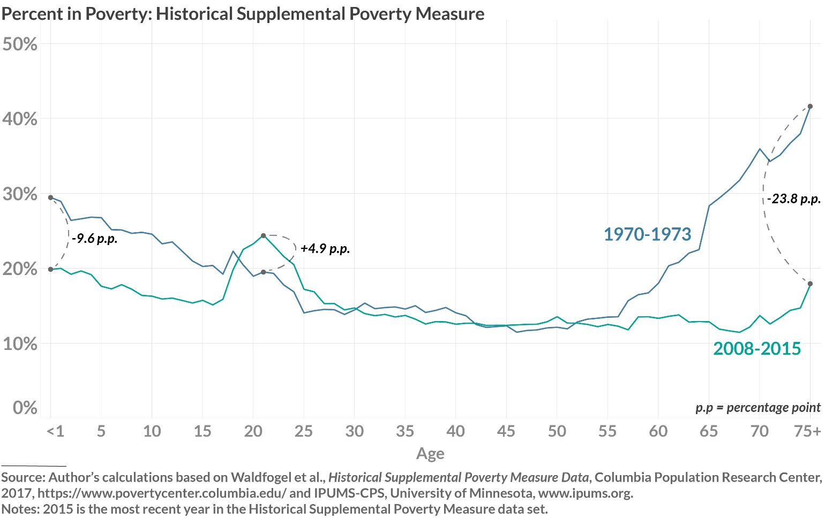
A note on our methods: we evaluate poverty over time and by age group using the Supplemental Poverty Measure (SPM) and a Historical Supplemental Poverty Measure (Historical SPM). We pool years by business cycle using dates from the National Bureau of Economic Research.
We find that young adult poverty has increased since the early 1970’s and is currently among the highest for any age group. In the last 40-50 years, anti-poverty efforts have lowered child poverty and elderly poverty, but have done much less to reduce poverty among young adults.
The spike in young adult poverty only formed in recent decades. While earlier years showed a relatively small increase in poverty at 18 years old, the 2008-2015 spike covers more young adults, according to data from the Historical SPM. Poverty among 19-24-year-olds has increased since the early 1970’s. The increase in young adult poverty is especially notable, given the progress during the same period in bringing down poverty rates among children and seniors.
The social safety net has had the greatest impact on poverty among the youngest and oldest. Working-age individuals benefit comparatively less from the social safety net. Assuming people make no behavioral adjustments in response to receiving benefits, the social safety net reduces poverty 10.3 percentage points for newborns and a full 45.5 percentage points for individuals age 75 or older. In stark contrast, the social safety net reduces poverty by only 4.8 percentage points for 21-year-olds.
These trends tell an important story: today, young adults have among the highest poverty rates, relative to the rest of the age distribution. But the descriptive analysis only tells us so much. What are the important social and economic forces driving these changes? In the last fifty years, the U.S. economy has produced a labor market yielding unfavorable returns for the average worker, particularly those without college degrees. Young adults, by virtue of being young, are more susceptible to the challenges facing low skill labor. They lack the labor market experience and human capital that can develop with age. Young, working-age adults have also largely been deprioritized from expansions in the social safety net. Some types of government assistance have helped young adults, with that amount increasing over time. For example, without government support through the EITC, poverty among young adults would be even worse than it is now. However, there is a stark difference between the impact of the EITC (and other government assistance) on youth versus young adults. In 2008-2015, government tax and transfer policies brought 17-year-old poverty down by an average of nearly double what it did for 21-year-olds, 9.1 percentage points and 4.8 percentage points, respectively.

The Historic SPM employs similar methodology as the original SPM, but extends it to earlier decades via various data sources and imputation methods. For more information, see: Fox, Liana, Christopher Wimer, Irwin Garfinkel, Neeraj Kaushal, and Jane Waldfogel. 2015. “Waging War on Poverty: Poverty Trends Using a Historical Supplemental Poverty Measure.” Journal of Policy Analysis and Management 34, no. 3: 567–92.
While the difference is less pronounced relative to 1967-1969, which encompass the earliest years of available data, we highlight the early 1970’s as the primary comparison group because it encompasses the earliest complete business cycle for which data is readily available.
Autor, David. “Skills, education, and the rise of earnings inequality among the ‘other 99 percent.’” Science 344, no. 6186: 843-851.

